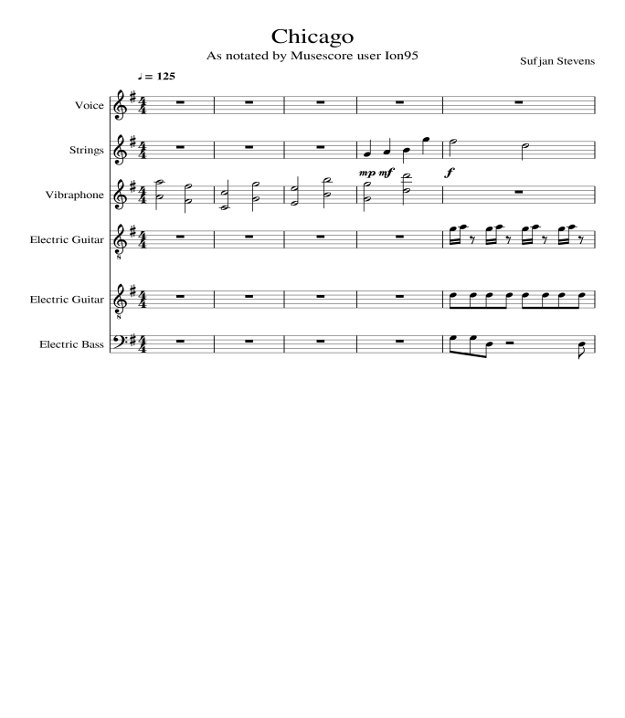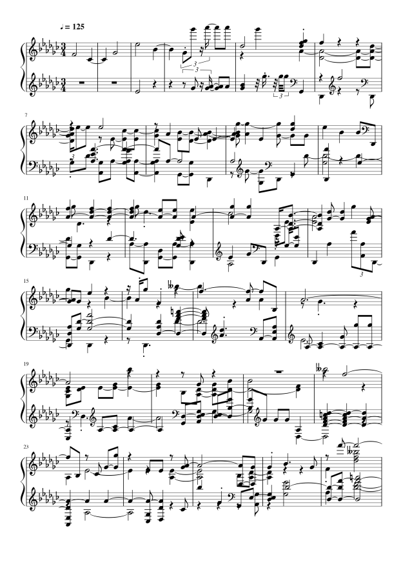The transcribed version of this piece contains many missing pieces of information and creates a piece of sheet music that I imagine would be nearly impossible for any musician to play. When placing the first page of the sheet music side by side (as below) this becomes apparent. At the top of the page the descriptive data about the piece is missing including the title and the composer. Yet, perhaps the most noticeable change is that the track has gone from containing six distinct instruments to a basic two stave layout (the clefs of which change sporadically throughout the piece) Changes include the key signature changing from 4/4 to ¾ which in turn changes the number of bars in the song. The transcribed piece also has 6 flat notes, whereas the original only had a single sharp on the F. The transcribed version also has clef changes throughout the piece – which would perhaps render it unsuitable for playback on many instruments. These are just some of the changes and these are not unexpected as the original piece was long and contained multiple instruments. A transcription from a midi file does not specify these features specifically and therefore is expectedly inaccurate.